Reverse Osmosis System
Deionized (DI) Water System
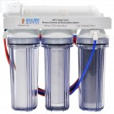
The Reverse osmosis Deionized water system supplied to William and Mary College will produce water suitable for use in laboratory applications. The system is comprised of two main parts; reverse osmosis (RO)/pre-treatment, distribution. The RO/pre-treat side of the system consists of a multi-media filter, carbon filer, water softener, 5 micron particle filer and RO unit.

“Dead Legs”
The deionized (DI) water system uses reverse osmosis to remove impurities from water. This system works by using a large amount of pressure to force tap water through a membrane that traps impurities. The delivery to the tap is done through a constantly circulating loop; however, there are “dead legs” from the loop to the tap. Dead legs are defined as any dead-ended section of pipe more than 4 pipe diameters long that occurs when a valve is closed. As a result of the presence of “dead legs,” the system can build up algae in the spigot piping.

User Operation
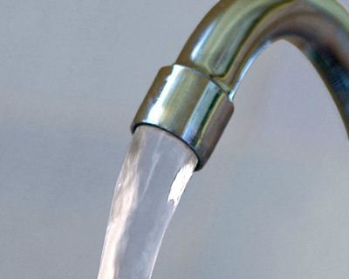
Let the tap run for 15 – 20 seconds before use of the deionized water system, to ensure that you are getting deionized water.

http://www.umaec.umich.edu/desguide/tech/15/15460.pdf

